BIKE RENTAL BOOKING

DONE BY

SHAJIVAN.S

ABSTRACTION

*Customers who want to take bikes on rent can register themselves as Customer and can take any bike on rent. customer can only take bike by coming to the location provided. The customer also has to upload some proofs to take the bike on rent.*

*Proofs like Aadhar card and pan card, are compulsory so that no one could run taking the bike. Any customer whose proofs are not uploaded and are not valid will not be allowed to take any bike on rent. This has one admin account that verifies the registering user and two types of user account.*

*This system has only one admin account and for more accounts Admin Can add. Admin can verify and register the user who is registering.*

1. *Login.jsp*

*<%--*

*Document : Login*

*Created on : 4 Sep, 2021, 12:03:31 AM*

*Author : ELCOT*

*--%>*

*<%@page contentType="text/html" pageEncoding="UTF-8"%>*

*<!DOCTYPE html>*

*<html>*

*<%@include file="header1.jsp" %>*

*<head>*

*<meta http-equiv="Content-Type" content="text/html; charset=UTF-8">*

*<title>JSP Page</title>*

*</head>*

*<body background="images/background.jpg" style = "background-repeat:no-repeat; background-size:100% 120%" >*

*<div align="right">*

*<form action="Logindao" method="POST">*

*<table style="border: solid green; border-spacing:40px; opacity: 1; background-color: whitesmoke">*

*<tr><td>*

*<h1 style="color: blue"> LOGIN PAGE </h1>*

*<div style="text-align:left ">*

*<input type="text" name="user" value="" placeholder=" Username"/><br/><br/>*

*<input type="password" name="pass" value="" placeholder="Password"/><br/><br/>*

*</div>*

*<input type="submit" value="SUBMIT" />*

*<div style="text-align: center">*

*<a href="Register.jsp" style="color:red"><h3>NEW USER</h3></a></div>*

*</td></tr></table>*

*</form>*

*</div>*

*</body>*

*<br><br><br><br><br><br><br><br><br><br><br><br><br><br><br><br><br><br><br><br><br><br><br><br><br><br><br>*

*<%@include file="footer.jsp" %>*

*</html>*

***Output***

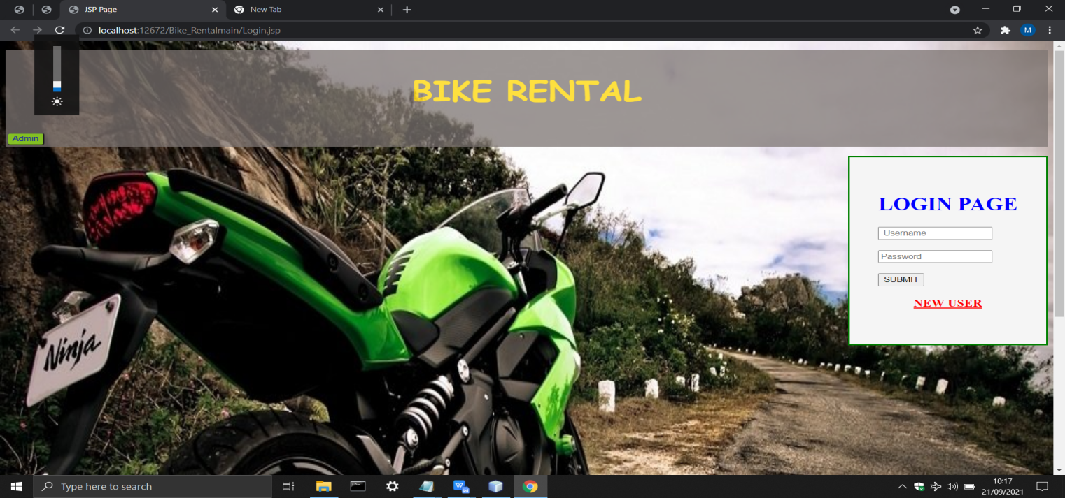

*Register.jsp*

*<%--*

*Document : Register*

*Created on : 2 Sep, 2021, 4:27:23 AM*

*Author : ELCOT*

*--%>*

*<%@page contentType="text/html" pageEncoding="UTF-8"%>*

*<!DOCTYPE html>*

*<html>*

*<%@include file="header.jsp" %>*

*<head>*

*<meta http-equiv="Content-Type" content="text/html; charset=UTF-8">*

*<title>Registration Page</title>*

*</head>*

*<body background="images/background4.jpeg" style = "background-repeat:no-repeat; background-size:100% 120%" >*

*<div align="center">*

*<h1 style="color: blue">Register Form</h1>*

*<form action="registrationdao" method="post">*

*<table style="border: solid blue; border-spacing: 18px; width: 17%; opacity: 1; background-color: seashell">*

*<tr><td>*

*<div align="left">*

*Username : <br><input type="text" name="user" value="" required="" autofocus=""/><br><br>*

*Password : <br><input type="password" name="npass" value="" required="" /><br><br>*

*Confirm Password : <br><input type="password" name="rpass" value="" required=""/><br><br>*

*Phone Number : <br><input type="text" name="phone" value="" required="" /><br><br>*

*Email-id : <br><input type="text" name="email" value="" required=""/><br><br>*

*Address :<br> <textarea name="address" rows="4" cols="20" required="" ></textarea><br><br>*

*</div>*

*Aadhar Card : <input type="file" name="Aadhar Card" value="" /><br><br>*

*Pan Card : <input type="file" name="Pan Card" value="" /><br><br>*

*<div align="center">*

*<input type="submit" value="SUBMIT" />&nbsp;&nbsp;&nbsp;*

*<input type="reset" value="RESET" /></div>*

*</td></tr>*

*</table>*

*</form>*

*</div>*

*</body><br><br><br><br><br><br><br><br><br><br><br><br>*

*<%@include file="footer.jsp" %>*

*</html>*

***OUTPUT***

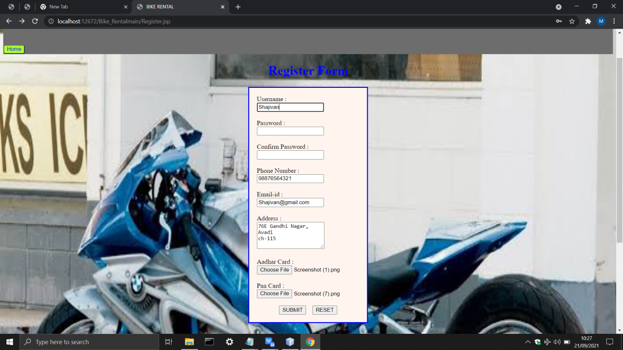

*Regerror.jsp*

*<%--*

*Document : regerror*

*Created on : 4 Sep, 2021, 12:11:05 AM*

*Author : ELCOT*

*--%>*

*<%@page contentType="text/html" pageEncoding="UTF-8"%>*

*<!DOCTYPE html>*

*<html>*

*<head>*

*<meta http-equiv="Content-Type" content="text/html; charset=UTF-8">*

*<title>JSP Page</title>*

*</head>*

*<body>*

*<h1>ERROR!</h1>*

*</body>*

*</html>*

*Bike.jsp*

*<%--*

*Document : Bike*

*Created on : 11 Sep, 2021, 12:20:03 AM*

*Author : ELCOT*

*--%>*

*<%@page contentType="text/html" pageEncoding="UTF-8"%>*

*<%@taglib prefix="c" uri="http://java.sun.com/jsp/jstl/core"%>*

*<!DOCTYPE html>*

*<html>*

*<jsp:include page="header.jsp"></jsp:include>*

*<jsp:include page="Template.jsp"></jsp:include>*

*<head>*

*<meta http-equiv="Content-Type" content="text/html; charset=UTF-8">*

*<title>BIKE RENTAL</title>*

*<style>*

*.big{*

*font-size: large;*

*}*

*</style>*

*</head>*

*<body>*

*<center>*

*<form action='<c:url value="/SessionServlet"/>' name="myform" method="post">*

*<table style="border: solid gray ; border-spacing: 50px; opacity: 0.8; background-color:buttonface"><tr>*

*<td><img src='images/1.webp' name="Bike" value="CFCMoto650GT" width='100' height='100'/>*

*<details><c:set var="CFCMoto650GT" value="1400"/>Price :<c:out value="${CFCMoto650GT}" /><br>*

*<c:set var="CFCMoto650GT" value="CFCMoto 650GT"/>Name : <c:out value="${CFCMoto650GT}"/></details><br/></td>*

*<td><img src='images/2.webp' name="Bike" value="BMWF900R" width='100' height='100' />*

*<details><c:set var="BMWF900R" value="1200"/>Price : <c:out value="${BMWF900R}"/><br>*

*<c:set var="BMWF900R" value="BMW F900 R"/>Name : <c:out value="${BMWF900R}"/></details><br/></td>*

*<td><img src='images/3.webp' name="Bike" value="RoyalEnfieldClassic350" width='100' height='100'/>*

*<details><c:set var="RoyalEnfieldClassic350" value="3000"/>Price : <c:out value="${RoyalEnfieldClassic350}"/><br>*

*<c:set var="RoyalEnfieldClassic350" value="Royal Enfield Classic350"/>Name : <c:out value="${RoyalEnfieldClassic350}"/></details><br/></td>*

*<br><br>*

*<td><img src='images/4.webp' name="Bike" value="YamahaMT15" width='100' height='100'/>*

*<details><c:set var="YamahaMT15" value="3400"/>Price : <c:out value="${YamahaMT15}"/><br>*

*<c:set var="YamahaMT15" value="Yamaha MT 15"/>Name : <c:out value="${YamahaMT15}"/></details><br/></td>*

*<td><img src='images/5.webp' name="Bike" value="RoyalEnfieldBullet350" width='100' height='100'/>*

*<details><c:set var="RoyalEnfieldBullet350" value="5400"/>Price : <c:out value="${RoyalEnfieldBullet350}"/><br>*

*<c:set var="RoyalEnfieldBullet350" value="Royal Enfield Bullet350"/>Name : <c:out value="${RoyalEnfieldBullet350}"/></details><br/></td>*

*<td><img src='images/6.webp' name="Bike" value="TVSApacheRTR160" width='100' height='100'/>*

*<details><c:set var="TVSApacheRTR160" value="5400"/>Price : <c:out value="${TVSApacheRTR160}"/><br>*

*<c:set var="TVSApacheRTR160" value="TVS Apache RTR 160"/>Name : <c:out value="${TVSApacheRTR160}"/></details><br/></td>*

*<td><img src='images/7.webp' name="Bike" value="BajajpulsarNS200" width='100' height='100'/>*

*<details><c:set var="BajajpulsarNS200" value="5400"/>Price : <c:out value="${BajajpulsarNS200}"/><br>*

*<c:set var="BajajpulsarNS200" value="Bajaj pulsar NS200"/>Name : <c:out value="${BajajpulsarNS200}"/></details><br/></td>*

*<td><img src='images/8.webp' name="Bike" value="TVSApacheRTR1604v" width='100' height='100'/>*

*<details><c:set var="TVSApacheRTR1604v" value="5400"/>Price : <c:out value="${TVSApacheRTR1604v}"/><br>*

*<c:set var="TVSApacheRTR1604v" value="TVS Apache RTR 160 4v"/>Name : <c:out value="${TVSApacheRTR1604v}"/></details><br/></td>*

*<td><img src='images/9.webp' name="Bike" value="YamahaFZSFIV3" width='100' height='100'/>*

*<details><c:set var="YamahaFZSFIV3" value="5400"/>Price : <c:out value="${YamahaFZSFIV3}"/><br>*

*<c:set var="YamahaFZSFIV3" value="YamahaFZS-FIV3"/>Name : <c:out value="${YamahaFZSFIV3}"/></details><br/></td>*

*<td><img src='images/10.webp' name="Bike" value="BajajPulsar220F" width='100' height='100'/>*

*<details><c:set var="BajajPulsar220F" value="5400"/>Price : <c:out value="${BajajPulsar220F}"/><br>*

*<c:set var="BajajPulsar220F" value="Bajaj Pulsar 220F"/>Name : <c:out value="${BajajPulsar220F}"/></details><br/></td><br>*

*</tr></table>*

*<table style="border:solid gray; border-spacing: 50px; opacity: 0.8; background-color:buttonface"><tr>*

*<td><img src='images/11.webp' name="Bike" value="BMWR1250GS" width='100' height='100'/>*

*<details><c:set var="BMWR1250GS" value="5400"/>Price : <c:out value="${BMWR1250GS}"/><br>*

*<c:set var="BMWR1250GS" value="BMW R 1250 GS"/>Name : <c:out value="${BMWR1250GS}"/></details><br/></td>*

*<td><img src='images/12.webp' name="Bike" value="BMWR1250GSAdventure" width='100' height='100'/>*

*<details><c:set var="BMWR1250GSAdventure" value="5400"/>Price : <c:out value="${BMWR1250GSAdventure}"/><br>*

*<c:set var="BMWR1250GSAdventure" value="BMW R 1250 GS Adventure"/>Name : <c:out value="${BMWR1250GSAdventure}"/></details><br/></td>*

*<td><img src='images/13.webp' name="Bike" value="BMWR1250R" width='100' height='100'/>*

*<details><c:set var="BMWR1250R" value="5400"/>Price : <c:out value="${BMWR1250R}"/><br>*

*<c:set var="BMWR1250R" value="BMW R 1250 R"/>Name : <c:out value="${BMWR1250R}"/></details><br/></td>*

*<td><img src='images/14.webp' name="Bike" value="YamahaYZFR15V3" width='100' height='100'/>*

*<details><c:set var="YamahaYZFR15V3" value="5400"/>Price : <c:out value="${YamahaYZFR15V3}"/><br>*

*<c:set var="YamahaYZFR15V3" value="Yamaha YZF R15 V3"/>Name : <c:out value="${YamahaYZFR15V3}"/></details><br/></td>*

*<td><img src='images/15.webp' name="Bike" value="RoyalEnfieldHimalayan" width='100' height='100'/>*

*<details><c:set var="RoyalEnfieldHimalayan" value="5400"/>Price : <c:out value="${RoyalEnfieldHimalayan}"/><br>*

*<c:set var="RoyalEnfieldHimalayan" value="Royal Enfield Himalayan"/>Name : <c:out value="${RoyalEnfieldHimalayan}"/></details><br/></td>*

*<td><img src='images/16.webp' name="Bike" value="RoyalEnfieldContinentalGT650" width='100' height='100'/>*

*<details><c:set var="RoyalEnfieldContinentalGT650" value="5400"/>Price : <c:out value="${RoyalEnfieldContinentalGT650}"/><br>*

*<c:set var="RoyalEnfieldContinentalGT650" value="Royal Enfield Continental GT 650"/>Name : <c:out value="${RoyalEnfieldContinentalGT650}"/></details><br/></td>*

*<td><img src='images/17.webp' name="Bike" value="YamahaFZFiVersion3" width='100' height='100'/>*

*<details><c:set var="YamahaFZFiVersion3" value="5400"/>Price : <c:out value="${YamahaFZFiVersion3}"/><br>*

*<c:set var="YamahaFZFiVersion3" value="Yamaha FZ-Fi Version3"/>Name : <c:out value="${YamahaFZFiVersion3}"/></details><br/></td>*

*<td><img src='images/18.webp' name="Bike" value="Jawa42" width='100' height='100'/>*

*<details><c:set var="Jawa42" value="5400"/>Price : <c:out value="${Jawa42}"/><br>*

*<c:set var="Jawa42" value="Jawa 42"/>Name : <c:out value="${Jawa42}"/></details><br/></td>*

*<td><img src='images/19.webp' name="Bike" value="KTM125Duke" width='100' height='100'/>*

*<details><c:set var="KTM125Duke" value="5400"/>Price : <c:out value="${KTM125Duke}"/><br>*

*<c:set var="KTM125Duke" value="KTM 125 Duke"/>Name : <c:out value="${KTM125Duke}"/></details><br/></td>*

*<td><img src='images/20.webp' name="Bike" value="KTM390DUKE" width='100' height='100'/>*

*<details><c:set var="KTM390DUKE" value="5400"/>Price : <c:out value="${KTM390DUKE}"/><br>*

*<c:set var="KTM390DUKE" value="KTM 390 DUKE"/>Name : <c:out value="${KTM390DUKE}"/></details><br/></td>*

*</tr></table></form>*

*<br><br><br><br><br>*

*<form action='<c:url value="/SessionServlet"/>' name='MyForm' method='POST'>*

*<table cellspacing="10" style="border: solid red; border-spacing: 15px; opacity: 1; background-color: seashell"> <tr>*

*<td bordercolor='white'><font color='darkorange' size="+2"> Select Item From Above : </font></td>*

*<td bordercolor='white'>*

*<div class="big">*

*<select name='Bike' >*

*<option value='CFCMoto650GT'>CFCMoto 650GT</option>*

*<option value='BMWF900R'>BMW F900 R</option>*

*<option value='RoyalEnfieldClassic350'>Royal Enfield Classic350</option>*

*<option value='YamahaMT15'>Yamaha MT 15</option>*

*<option value='RoyalEnfieldBullet350'>Royal Enfield Bullet350</option>*

*<option value='TVSApacheRTR160'>TVS Apache RTR 160</option>*

*<option value='BajajPulsarNS200'>Bajaj Pulsar NS200</option>*

*<option value='TVSApacheRTR1604V'>TVS Apache RTR 160 4V</option>*

*<option value='YamahaFZSF1V3'>Yamaha FZS-F1 V3</option>*

*<option value='BajajPulsar220F'>Bajaj Pulsar 220F</option>*

*<option value='BMWR1250GS'>BMW R 1250 GS</option>*

*<option value='BMWR1250GSAdventure'>BMW R 1250 GS Adventure</option>*

*<option value='BMWR1250R'>BMW R 1250 R</option>*

*<option value='YamahaYZFR15V3'>Yamaha YZF R15 V3</option>*

*<option value='RoyalEnfieldHimalayan'>Royal Enfield Himalayan</option>*

*<option value='RoyalEnfieldContinentalGT650'>Royal Enfield Continental GT 650</option>*

*<option value='YamahaFZFiVersion3'>Yamaha FZ-Fi Version 3</option>*

*<option value='Jawa42'>Jawa 42</option>*

*<option value='KTM125Duke'>KTM 125 Duke</option>*

*<option value='KTM390DUKE'>KTM 390 DUKE</option>*

*</select>*

*</div>*

*<tr>*

*<td bordercolor='white'><font color='darkorange' size="+2"> Enter the Date : </font> </td><td bordercolor='white'>*

*<input type= 'date' name='Date' required="" autofocus=""></td> </tr>*

*<tr>*

*<td bordercolor='white'><font color='darkorange' size="+2"> Enter the No of Days : </font> </td><td bordercolor='white'>*

*<input type= 'number' name='Days' required="" autofocus=""></td> </tr> <tr><td align="center">*

*<input type='hidden' value='sBike' name='PageName'/> </td> </tr>*

*<tr><td bordercolor='red' style="size: 5" >*

*<input type='submit' value='Next' size="+2" ></td>*

*</tr></table></form>*

*</center> </body>*

*<br><br><br><br><br><br>*

*<jsp:include page="footer.jsp"></jsp:include>*

*</html>*

***OUTPUT***

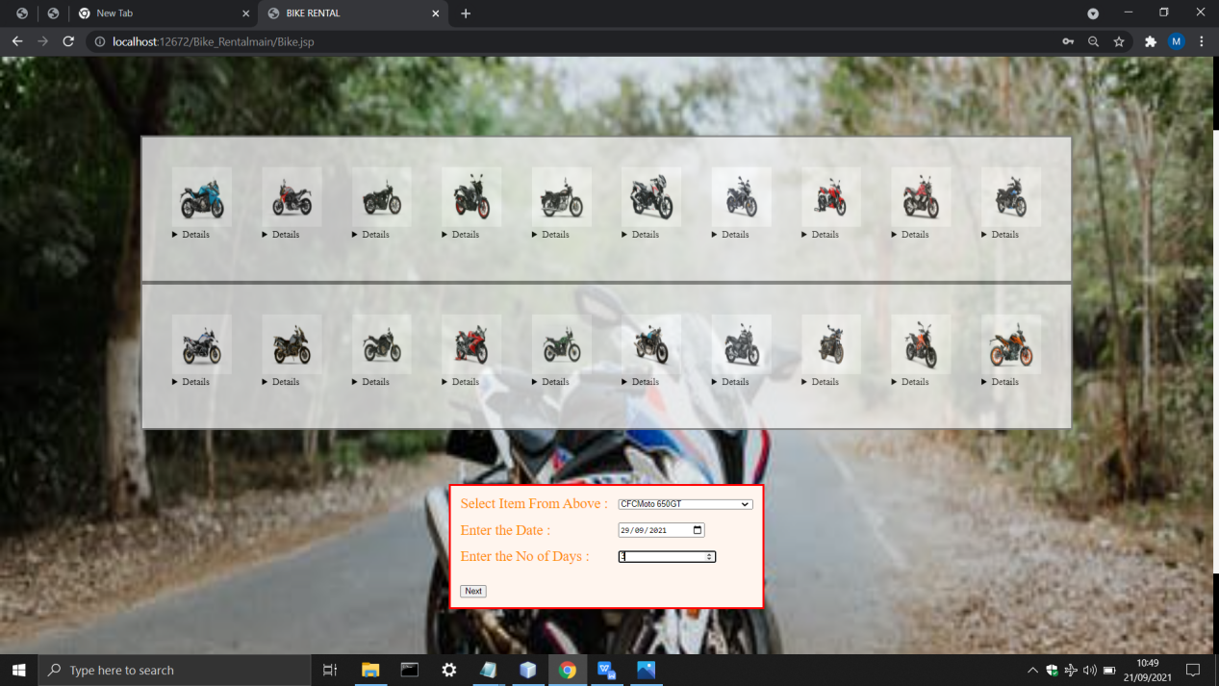

*Customer.jsp*

*<%--*

*Document : Customer*

*Created on : 30 Aug, 2021, 7:16:19 PM*

*Author : ELCOT*

*--%>*

*<%@taglib prefix="c" uri="http://java.sun.com/jsp/jstl/core" %>*

*<%@taglib prefix="fmt" uri="http://java.sun.com/jsp/jstl/fmt" %>*

*<!DOCTYPE html>*

*<html>*

*<jsp:include page="header.jsp"></jsp:include>*

*<body background="images/background3.jpeg" style = "background-repeat:no-repeat; background-size:100% 100%" >*

*<head><title>Bike Page</title></head>*

*<body>*

*<td valign="top" rowspan="200"colspan="80">*

*<table>*

*<tr>*

*<c:set var="Bike" value="${sessionScope.selBike}"/>*

*<c:set var="Date" value="${sessionScope.selDate}"/>*

*<c:set var="Days" value="${sessionScope.selDays}"/>*

*<c:choose>*

*<c:when test="${Bike=='CFCMoto650GT'}">*

*<c:set var="price" value="35000"/>*

*</c:when>*

*<c:when test="${Bike=='BMWF900R'}">*

*<c:set var="price" value="30000"/>*

*</c:when>*

*<c:when test="${Bike=='RoyalEnfieldClassic350'}">*

*<c:set var="price" value="30000"/>*

*</c:when>*

*<c:when test="${Bike=='YamahaMT15'}">*

*<c:set var="price" value="40000"/>*

*</c:when>*

*<c:when test="${Bike=='RoyalEnfieldBullet350'}">*

*<c:set var="price" value="40000"/>*

*</c:when>*

*<c:when test="${Bike=='TVSApacheRTR160'}">*

*<c:set var="price" value="45000"/>*

*</c:when>*

*<c:when test="${Bike=='BajajPulsarNS200'}">*

*<c:set var="price" value="60000"/>*

*</c:when>*

*<c:when test="${Bike=='TVSApacheRTR1604V'}">*

*<c:set var="price" value="55000"/>*

*</c:when>*

*<c:when test="${Bike=='YamahaFZS-F1V3'}">*

*<c:set var="price" value="40000"/>*

*</c:when>*

*<c:when test="${Bike=='BajajPulsar220F'}">*

*<c:set var="price" value="45000"/>*

*</c:when>*

*<c:when test="${Bike=='BMWR1250GS'}">*

*<c:set var="price" value="45000"/>*

*</c:when>*

*<c:when test="${Bike=='BMWR1250GSAdventure'}">*

*<c:set var="price" value="25000"/>*

*</c:when>*

*<c:when test="${Bike=='BMWR1250R'}">*

*<c:set var="price" value="25000"/>*

*</c:when>*

*<c:when test="${Bike=='YamahaYZFR15V3'}">*

*<c:set var="price" value="30000"/>*

*</c:when>*

*<c:when test="${Bike=='RoyalEnfieldHimalayan'}">*

*<c:set var="price" value="28000"/>*

*</c:when>*

*<c:when test="${Bike=='RoyalEnfieldContinentalGT650'}">*

*<c:set var="price" value="35000"/>*

*</c:when>*

*<c:when test="${Bike=='YamahaYZFR15V3'}">*

*<c:set var="price" value="28000"/>*

*</c:when>*

*<c:when test="${Bike=='Jawa42'}">*

*<c:set var="price" value="50000"/>*

*</c:when>*

*<c:when test="${Bike=='KTM125Duke'}">*

*<c:set var="price" value="40000"/>*

*</c:when>*

*<c:when test="${Bike=='KTM390DUKE'}">*

*<c:set var="price" value="40000"/>*

*</c:when>*

*</c:choose>*

*</tr></table><br>*

*<font align='center' color='red' size='+3'>Thank you Enjoy your riding with our Bike,Here check your booking details.*

*</font>*

*<br/>*

*<br/>*

*<br/>*

*<div>*

*<table cellspacing='10' align='center'border='2' bordercolor='black' style="background-color: aliceblue">*

*<tr><td bordercolor='white' ><font size="+2">Bike you have selected:<td COLSPAN='2'bordercolor='white'><font size="+2"><c:out value="${Bike}"/>*

*<tr><td bordercolor='white'><font size="+2">Date you booked:<td COLSPAN='2' bordercolor='white'><font size="+2"><c:out value="${Date}"/>*

*<tr><td bordercolor='white'><font size="+2">Total number of days:<td bordercolor='white'><font size="+2"><c:out value="${Days}"/>*

*<tr><td bordercolor='white'><b><font size="+2">Total Package Cost</b>:*

*<td bordercolor='white'><b><font size="+2"><fmt:formatNumber type="Currency" value="${price}"/></b>*

*</td></tr>*

*<table align="center">*

*<tr><td>*

*<form action="log">*

*<input type="submit" value="log out" style="color:blue;background-color:yellowgreen;border-radius:4px"/> </td></tr>*

*</table>*

*</form>*

*</table>*

*</div> </form>*

*</body>*

*<br><br><br><br><br><br><br><br><br><br><br><br><br><br><br><br><br><br><br><br><br><br><br><br><br><br><br><br><br><br><br><br><br><br><br><br><br><br><br><br>*

*<jsp:include page="footer.jsp"></jsp:include>*

*</html>*

***OUTPUT***

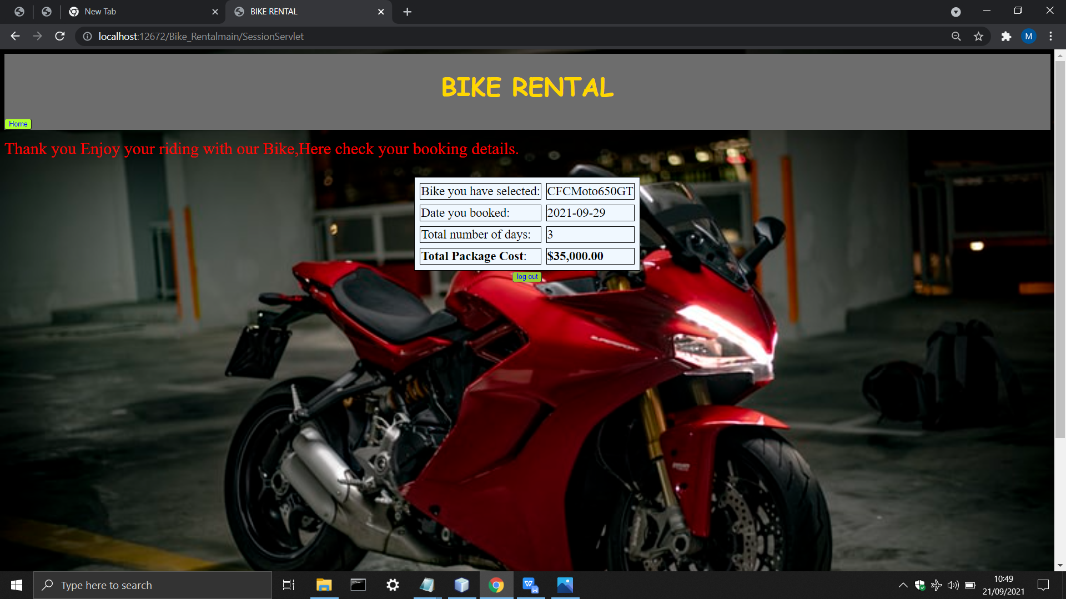

*Admin.jsp*

*<%--*

*Document : Login*

*Created on : 4 Sep, 2021, 12:03:31 AM*

*Author : ELCOT*

*--%>*

*<%@page contentType="text/html" pageEncoding="UTF-8"%>*

*<!DOCTYPE html>*

*<html>*

*<%@include file="header1.jsp" %>*

*<head>*

*<meta http-equiv="Content-Type" content="text/html; charset=UTF-8">*

*<title>JSP Page</title>*

*</head>*

*<body background="images/background1.jpg" style = "background-repeat:no-repeat; background-size:100% 130%" >*

*<div align="right">*

*<form action="adminlog.jsp" method="POST">*

*<table style="border: solid red; border-spacing:40px; opacity: 1; background-color: whitesmoke">*

*<tr><td>*

*<h1 style="color: blue"> ADMIN PAGE </h1>*

*<div style="text-align:left ">*

*<input type="text" name="user" value="" placeholder=" Username"/><br/><br/>*

*<input type="password" name="pass" value="" placeholder="Password"/><br/><br/>*

*</div>*

*<input type="submit" value="SUBMIT" />*

*<div style="text-align: center">*

*<a href="Register.jsp" style="color:red"><h3>NEW USER</h3></a></div>*

*</td></tr></table>*

*</form>*

*</div>*

*</body>*

*<br><br><br><br><br><br><br><br><br><br><br><br><br><br><br><br><br><br><br><br><br><br><br><br><br><br><br>*

*<%@include file="footer.jsp" %>*

*</html>*

***OUTPUT***

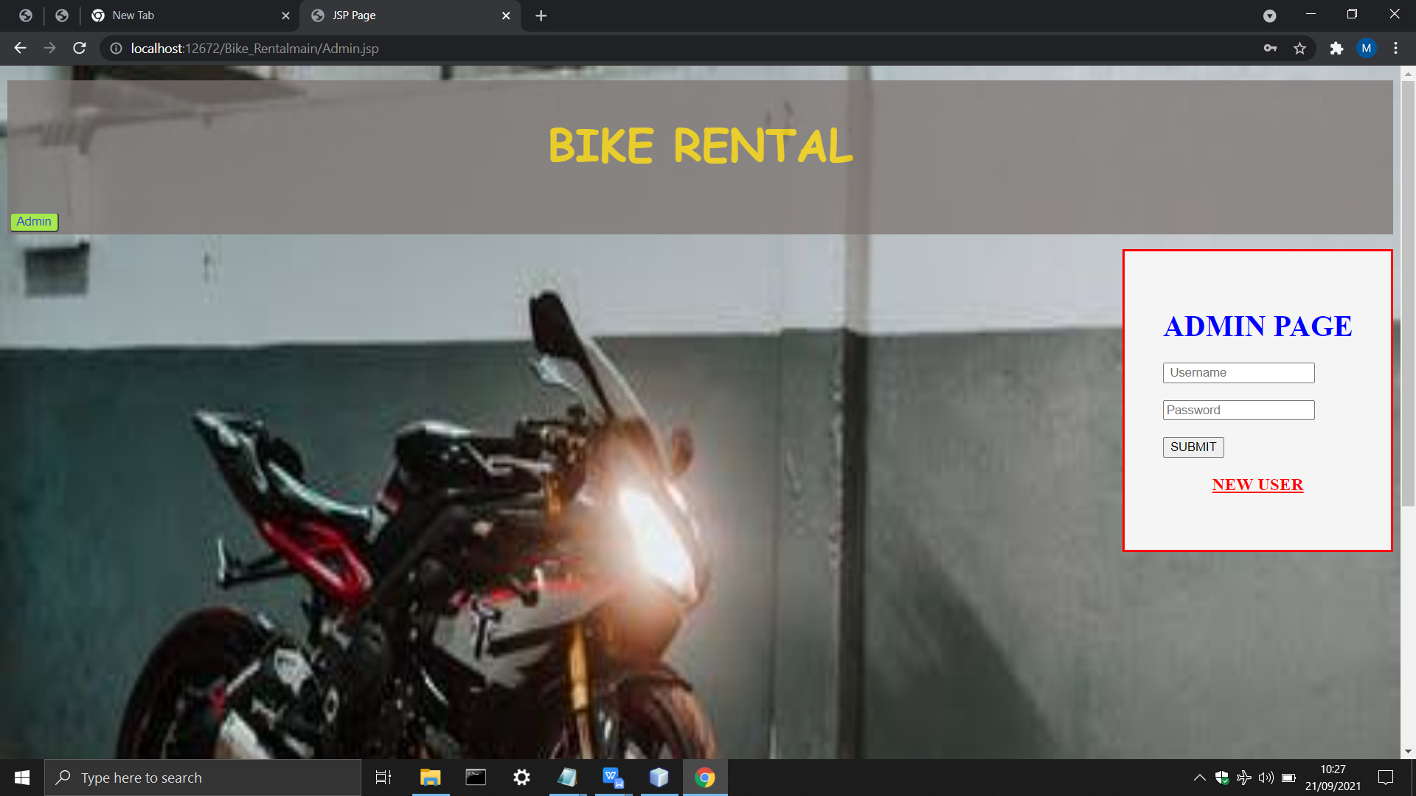

*Adminlog.jsp*

*<%--*

*Document : adminlog*

*Created on : 19 Sep, 2021, 5:04:39 AM*

*Author : ELCOT*

*--%>*

*<%@page contentType="text/html" pageEncoding="UTF-8"%>*

*<!DOCTYPE html>*

*<html>*

*<head>*

*<meta http-equiv="Content-Type" content="text/html; charset=UTF-8">*

*<title>JSP Page</title>*

*</head>*

*<body>*

*<h1>WELCOME ADMIN!</h1>*

*</body>*

*</html>*

*Logindao.java*

*package control;*

*import java.io.IOException;*

*import java.io.PrintWriter;*

*import java.sql.Connection;*

*import java.sql.DriverManager;*

*import java.sql.PreparedStatement;*

*import java.sql.ResultSet;*

*import java.sql.SQLException;*

*import javax.servlet.RequestDispatcher;*

*import javax.servlet.ServletException;*

*import javax.servlet.annotation.WebServlet;*

*import javax.servlet.http.HttpServlet;*

*import javax.servlet.http.HttpServletRequest;*

*import javax.servlet.http.HttpServletResponse;*

*/\*\**

*\**

*\* @author Shajivan S*

*\*/*

*@WebServlet(name = "Logindao", urlPatterns = {"/Logindao"})*

*public class Logindao extends HttpServlet {*

*protected void processRequest(HttpServletRequest request, HttpServletResponse response)*

*throws ServletException, IOException {*

*response.setContentType("text/html;charset=UTF-8");*

*try (PrintWriter out = response.getWriter()) {*

*}*

*}*

*@Override*

*protected void doPost(HttpServletRequest request, HttpServletResponse response)*

*throws ServletException, IOException {*

*PrintWriter out = response.getWriter();*

*String uname=request.getParameter("user");*

*String npass=request.getParameter("pass");*

*try{*

*Class.forName("org.apache.derby.jdbc.ClientDriver");*

*Connection con=DriverManager.getConnection("jdbc:derby://localhost:1527/Shajivan","Shajivan","12345");*

*System.out.println("connected using Login page");*

*String sql="select * from SHAJIVAN.REGISTER where uname=? and npass=?";*

*PreparedStatement ps=con.prepareStatement(sql);*

*ps.setString(1, uname);*

*ps.setString(2, npass);*

*String unameDB="";*

*String npassDB="";*

*ResultSet rs=ps.executeQuery();*

*if(rs.next())*

*{*

*unameDB=rs.getString("uname");*

*npassDB=rs.getString("npass");*

*System.out.println("Database username : "+unameDB);*

*System.out.println("Database password : "+npassDB);*

*if((uname.equals(unameDB))&&(npass.equals(npassDB))){*

*System.out.println("Inside If");*

*RequestDispatcher rd=request.getRequestDispatcher("Bike.jsp");*

*rd.forward(request, response);*

*}*

*}*

*else{*

*RequestDispatcher rd=request.getRequestDispatcher("Login.jsp");*

*out.println("<!DOCTYPE html>");*

*out.println("<html>");*

*out.println("<head>");*

*out.println("</head>");*

*out.println("<body>");*

*out.println("<center>");*

*out.println("<h1 style='color: yellow'>Invalid Credentials</h1>");*

*out.println("</center>");*

*out.println("</body>");*

*out.println("</html>");*

*rd.include(request, response);*

*}*

*}*

*catch(ClassNotFoundException | SQLException e){*

*System.out.println("Error From Login : "+e.getMessage());*

*}*

*}*

*@Override*

*protected void doGet(HttpServletRequest request, HttpServletResponse response)*

*throws ServletException, IOException {*

*processRequest(request, response);*

*}*

*@Override*

*public String getServletInfo() {*

*return "Short description";*

*}*

*}*

*Registrationdao.java*

*package control;*

*import java.io.IOException;*

*import static java.lang.System.out;*

*import java.sql.Connection;*

*import java.sql.DriverManager;*

*import java.sql.PreparedStatement;*

*import java.sql.SQLException;*

*//import java.sql.Statement;*

*import javax.servlet.RequestDispatcher;*

*import javax.servlet.ServletException;*

*import javax.servlet.annotation.WebServlet;*

*import javax.servlet.http.HttpServlet;*

*import javax.servlet.http.HttpServletRequest;*

*import javax.servlet.http.HttpServletResponse;*

*/\*\**

*\**

*\* @author ELCOT*

*\*/*

*@WebServlet(name = "registrationdao", urlPatterns = {"/registrationdao"})*

*public class registrationdao extends HttpServlet {*

*protected void processRequest(HttpServletRequest request, HttpServletResponse response)*

*throws ServletException, IOException {*

*response.setContentType("text/html;charset=UTF-8");*

*// Statement st=null;*

*// String mg="";*

*String uname=request.getParameter("user");*

*String email=request.getParameter("email");*

*String npass=request.getParameter("npass");*

*String rpass=request.getParameter("rpass");*

*String address=request.getParameter("address");*

*String phone=request.getParameter("phone");*

*try {*

*Connection con;*

*Class.forName("org.apache.derby.jdbc.ClientDriver");*

*con=DriverManager.getConnection("jdbc:derby://localhost:1527/Shajivan","Shajivan","12345");*

*System.out.println("connected");*

*String sql = "insert into SHAJIVAN.REGISTER(uname,email,npass,rpass,address,phone) values(?,?,?,?,?,?)";*

*PreparedStatement ps=con.prepareStatement(sql);*

*ps.setString(1, uname);*

*ps.setString(2, email);*

*ps.setString(3, npass);*

*ps.setString(4, rpass);*

*ps.setString(5, address);*

*ps.setString(6, phone);*

*if(npass.equals(rpass))*

*{*

*ps.executeUpdate();*

*RequestDispatcher rds=request.getRequestDispatcher("Login.jsp");*

*rds.forward(request, response);*

*}*

*else{*

*RequestDispatcher rds=request.getRequestDispatcher("regerror.jsp");*

*rds.forward(request, response);*

*}*

*}*

*catch(ClassNotFoundException | SQLException e){*

*out.println("Error in DB : "+e.getMessage());*

*}*

*}*

*@Override*

*protected void doGet(HttpServletRequest request, HttpServletResponse response)*

*throws ServletException, IOException {*

*processRequest(request, response);*

*}*

*@Override*

*protected void doPost(HttpServletRequest request, HttpServletResponse response)*

*throws ServletException, IOException {*

*processRequest(request, response);*

*}*

*@Override*

*public String getServletInfo() {*

*return "Short description";*

*}// </editor-fold>*

*}*

*SessionServlet.java*

*package control;*

*import java.io.IOException;*

*import java.io.PrintWriter;*

*import javax.servlet.RequestDispatcher;*

*import javax.servlet.ServletException;*

*import javax.servlet.annotation.WebServlet;*

*import javax.servlet.http.HttpServlet;*

*import javax.servlet.http.HttpServletRequest;*

*import javax.servlet.http.HttpServletResponse;*

*import javax.servlet.http.HttpSession;*

*/\*\**

*\**

*\* @author ELCOT*

*\*/*

*@WebServlet(name = "SessionServlet", urlPatterns = {"/SessionServlet"})*

*public class SessionServlet extends HttpServlet {*

*protected void processRequest(HttpServletRequest request, HttpServletResponse response)*

*throws ServletException, IOException {*

*response.setContentType("text/html;charset=UTF-8");*

*try (PrintWriter out = response.getWriter()) {*

*HttpSession session = request.getSession(false);*

*String requestingPageName = request.getParameter("PageName");*

*if(requestingPageName.equals("sBike"))*

*{*

*String selectedBike = request.getParameter("Bike");*

*String selectedDate = request.getParameter("Date");*

*String selectedDays = request.getParameter("Days");*

*session.setAttribute("selBike", selectedBike);*

*session.setAttribute("selDate", selectedDate);*

*session.setAttribute("selDays", selectedDays);*

*RequestDispatcher dispatch =request.getRequestDispatcher("Customer.jsp");*

*dispatch.forward(request, response);*

*}*

*else*

*{*

*RequestDispatcher dispatch =request.getRequestDispatcher("regerror.jsp");*

*dispatch.forward(request, response);*

*}*

*}*

*}*

*@Override*

*protected void doPost(HttpServletRequest request, HttpServletResponse response)*

*throws ServletException, IOException {*

*processRequest(request, response);*

*}*

*@Override*

*protected void doGet(HttpServletRequest request, HttpServletResponse response)*

*throws ServletException, IOException {*

*processRequest(request, response);*

*}*

*@Override*

*public String getServletInfo() {*

*return "Short description";*

*}*

*}*

*Header.jsp*

*<%--*

*Document : header*

*Created on : Sep 9, 2021, 1:30:06 PM*

*Author : ELCOT*

*--%>*

*<%@page contentType="text/html" pageEncoding="UTF-8"%>*

*<!DOCTYPE html>*

*<html>*

*<head>*

*<meta http-equiv="Content-Type" content="text/html; charset=UTF-8">*

*<title>BIKE RENTAL</title>*

*<style>*

*.header{*

*text-align: left;*

*font-size: 20px;*

*background-color: graytext;*

*color: white;*

*padding: 1px;*

*}*

*</style>*

*</head>*

*<body>*

*<div class="header">*

*<h1 style="color: whitesmoke; text-align: center"><font style="font-family: Comic Sans MS" color="gold" size="+6">BIKE RENTAL</font></h1>*

*<a href="Login.jsp"><input type="submit" value="Home" style="color: blue;background-color:greenyellow;border-radius:4px"/></a>*

*</div>*

*</body>*

*</html>*

***OUTPUT***



*Footer.jsp*

*<%--*

*Document : footer*

*Created on : 4 Sep, 2021, 12:24:13 AM*

*Author : ELCOT*

*--%>*

*<%@page contentType="text/html" pageEncoding="UTF-8"%>*

*<!DOCTYPE html>*

*<html>*

*<head>*

*<meta http-equiv="Content-Type" content="text/html; charset=UTF-8">*

*<title>BIKE RENTAL</title>*

*<style>*

*.footer{*

*text-align: left;*

*font-size: 15px;*

*background-color: black;*

*color: white;*

*padding: 1px;*

*opacity: 0.75;*

*}*

*</style>*

*</head>*

*<body>*

*<div class="footer">*

*<p><font size="+2">E-mail :</font><a href="mailto:alexmartin.shaji@gmail.com" style="color:orangered "><font size="+2"> alexmartin.shaji@gmail.com</font></a></p>*

*<p><font size="+2">Phone :</font><a href="tel:044-90250878" style="color:red"><font size="+2">044-90250878</font></a> </p>*

*<p><font size="+2">Mobile :</font><a href="tel:9025097889" style="color:red"><font size="+2">9025097889</font></a> </p>*

*</div>*

*</body>*

*</html>*

***OUTPUT***

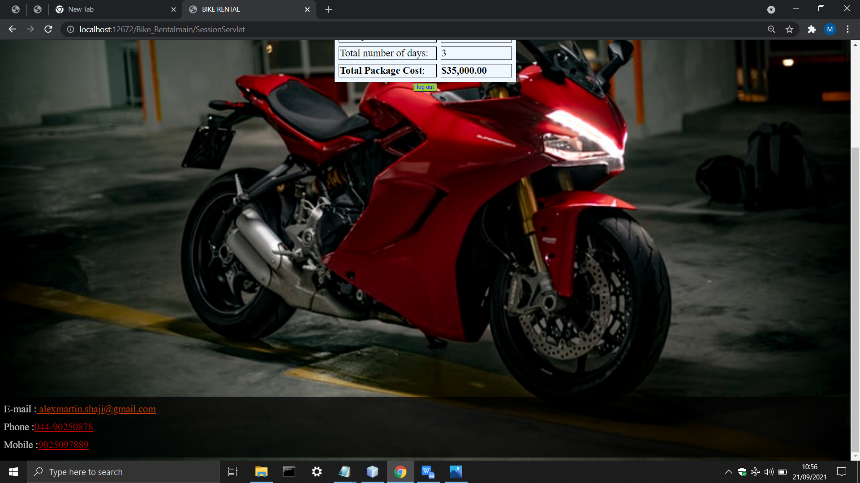

Conclusion:

In this process Bike Rental booking so it proceed with this project . And this project is small process and you get some conclusion from this project

APPLICATION USED:

NETBEAN IDE IN 8.2